The Best Sport Drink:
A Feasibility report

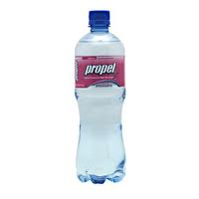
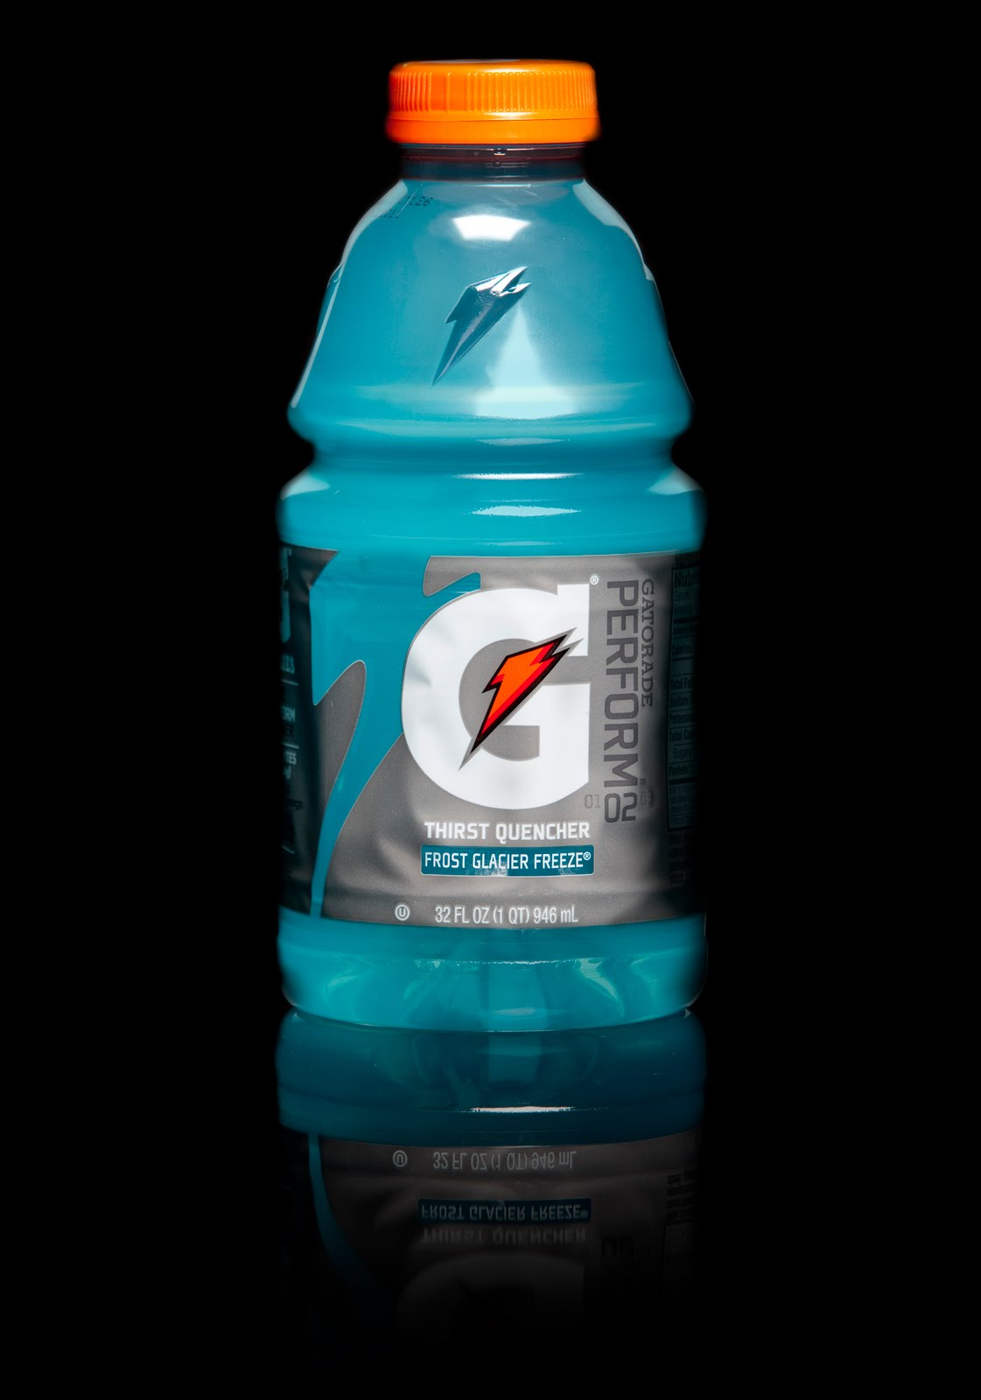
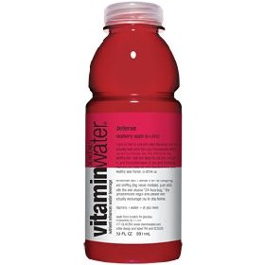
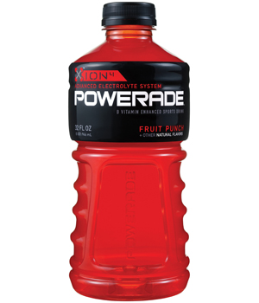

By:

Garrett Hock, Pedro Marquez, Brenda Pintor

May 2, 2013

For:

TECM 2700 Cabrera

Table of Contents

Table of Contents iii
Introduction v
Options: v
Methods of Evaluation 7
Taste 7
Price 7
Calories 7
Electrolytes 7
Limits 7
Results of Evaluation 9
Price 9
Calories 10
Overall Data 10
Conclusion 11
Recommendation 11

Introduction

Do you ever find yourself wondering if you could be getting a better quality of drink for a better price? Are those sports drinks actually better just because they cost more? In this feasibility test, we determined what sports drink is the best. Gatorade seems to be the most popular sports drink out there, but how do other brands compare to it and to what extent? We evaluated four different sport drink brands including: Gatorade, Powerade, Propel, and Vitamin Water. We compared prices, calories, electrolytes, and of course the taste of each brand to find which one is the best.
In the report that follows, we explain how we obtained our results for the overall best sports drink according to our preferences.

Options:
The sport drinks we are evaluating are Gatorade, Powerade, Propel, and Vitamin Water. These are the most conveniently available in neighborhood Wal-Mart’s, Target’s, and around North Texas. These are all very common especially Gatorade and so we want to test it against other brands considering taste, price, calories, and electrolytes.
Option 1: Gatorade. Gatorade is the most popular sport drink because of its great taste and advertising.
Option 2: Powerade. Powerade is the next most common drink and so we want to compare the taste to the leading Gatorade brand.
Option 3: Propel. Although it is in every Wal-Mart it isn’t a very popular brand and for that reason we are comparing it to others to see if it’s just because people have never tried it.
Option 4: Vitamin Water. We chose Vitamin water because of its variety in flavors and its popularity

Methods of Evaluation

We evaluated the drink choices using the following criteria:
• Taste
• Price
• Calories
• Electrolytes

Taste
We picked taste as a category for our criteria because it is an important deciding factor when people are out buying a drink. People want a drink that tastes good while helping them perform.
We conducted a blind survey and asked 10 people to rate the product on a scale of 1-4, 1 being the poorest score and 4 being the best.

Price
We picked price as a category for our criteria because as college students we are always trying to save money in every way we can while still getting the best quality product.
We obtained the price for a bottle of each product and then measured the price per ounce by dividing the two. Price/Ounces

Calories
We picked calories as a category for our criteria because calories are used as a health meter many people look for low calorie drinks when purchasing a drink.
We obtained the amount of calories per serving on each bottle of the products and then compared them and saw which was the lowest.

Electrolytes
We picked electrolytes as a category for our criteria because for athletes it is important to have electrolytes in their drink to keep them hydrated and performing their best.
We obtained weather or not each product had electrolytes and compared.

Limits
It is time consuming to test a lot of people’s opinion on the different tastes of all four drinks, because of this we were only able to test a small group of people which isn’t as accurate as testing a hundred.

Results of Evaluation

Price

- Gatorade $1.00 for 32 oz.

- Powerade $.80 for 32 oz.

- Propel $1.00 for 24 oz.

- Vitamin Water $1.99 for 20 oz.
We took the price of each option and divided it by the ounce per bottle to find the price per ounce.

Calories

Overall Data
 | Price (per oz.) | Calories | Taste | Electrolytes | Overall Rank
Gatorade | $.031 per oz. | 80 | 3.5 | Y | 1
Powerade | $.025 per oz. | 80 | 3 | Y | 2
Propel | $.042 per oz. | 0 | 1.6 | N | 4
Vitamin Water | $.10 per oz. | 72 | 1.9 | Y | 3

Conclusion

Taste was, for sure, the largest factor when we decided picking which of these sports drink was the best. In conclusion, we can say that Gatorade is the best tasting products out of 3 other sports drinks according to our results, but it tied for having the most calories. Overall Gatorade was the best sports drink for its price, taste, and electrolytes combined. The second best Sports drink was Powerade. Its price, taste, and electrolytes combined made it the second best. The sports drink that placed third was Vitamin Water. Vitamin Water beat out Propel in taste, but it cost more and had more calories than Propel. And finally, Propel came in last place. Propel had no calories which is a plus, but it also has zero electrolytes which set it back. It was by far the worst tasting sports drink to our test subjects.

Recommendation

Among these sports drinks, Gatorade was the best tasting. Even though Gatorade had the most calories and isn’t the cheapest, we recommend buying Gatorade for the best tasting sports drink.

